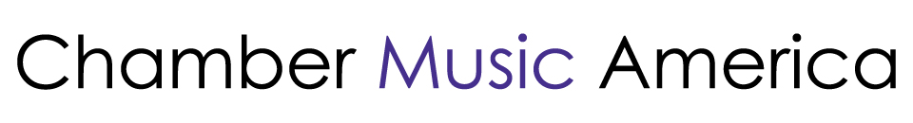

2023 Ensemble Forward
SAMPLE MEMORANDUM OF UNDERSTANDING
BETWEEN ENSEMBLE AND COACH

Date: ____________

Ensemble Name: _________________________________

Ensemble Primary Contact: ____________________________

Street Address: ___________________________________

[New York City Borough], State, Zip Code: ________________________________

Dear Chamber Music America:

This letter confirms that [Ensemble] intends to partner with [Coach] for five Coaching sessions, pending funding from Chamber Music America’s Ensemble Forward grant program in accordance with the following:

- Five Ensemble Coaching sessions in New York City. Location: TBD
- Payment of $2,500 for 5 sessions ($500/session) for a minimum of 90 minutes per session
- Sessions will take place January 1 – December 31, 2023
- The Coach is able to provide verification of U.S. residence status: a valid U.S. passport, a U.S. birth certificate, a Report of Birth Abroad form (FS-240), a USCIS certificate of citizenship or naturalization, or permanent resident status/green card.

Ensemble Primary Contact (Print):

Signature: | Date:
Coach (Print)

Signature: | Date:

