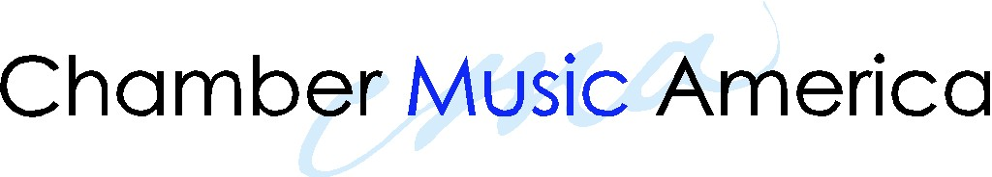

NEW JAZZ WORKS CMA CONFERENCE REQUEST

1. Please Complete
Grantee Name: |  | Date:
Ensemble Name: |  | Year of Award:
Address:
Phone: | Email:

2. Complimentary Conference Registration
I would like to attend the upcoming CMA National Conference
I would like to attend the first-time registrant orientation
I would like to be assigned a conference mentor

- Hotel and Travel Subsidy
Complete this section if your CMA contract indicates that you are eligible. CMA partially subsidizes conference travel and hotel costs, on a limited basis, for grantees who live more than 200 miles outside New York. Please refer to the CMA website for the Westin Hotel conference rate. If you opt for an alternative hotel, the room rate may be up to, and not exceeding, that of the Westin Hotel conference rate. CMA subsidizes only the room, incidentals are your responsibility. Ground travel is subsidized up to $200 total. CMA reimburses gas @ $.55/mile or through dated gas receipts.
Cost | Detail | Amount
Hotel (#nights x cost/night)
Airplane
Ground Travel (please itemize)
Total

4. For Other Expenses such as, showcasing, exhibiting, attending the luncheon, banquet and/or concerts, mailing list and advertising, use the Payment Request Form. For more information about these fees, contact Sherry Robinson, conference and events manager, srobinson@chamber-music.org. For information on how to apply the other conference costs to your NJW grant, contact Jeanette Vuocolo, program director, CMA Jazz, gshinde@chamber-music.org

5. Please Sign: To the best of my knowledge, the data reported above are correct and all outlays will be made in accordance with grant conditions. Payment is due and has not been previously requested.
Signature: | Date:

6. Send by regular mail or email to: Chamber Music America, CMA Jazz, NJW Conference Request, 12 West 32nd Street, 7th floor, NY, NY 10001; (212) 967-9747 F; gshinde@chamber-music.org

7. CMA Approval
Signature: | Date:
Grantee must receive CMA approval before engaging in any Grant expenditure that requires a Payment Request Form. CMA approval will be sent via email.

